Name: Evan Meyer

Title: Guys and Dolls

Course: Theatre Appreciation

Professor: Wallace Bridges

Date: April 4th, 2023

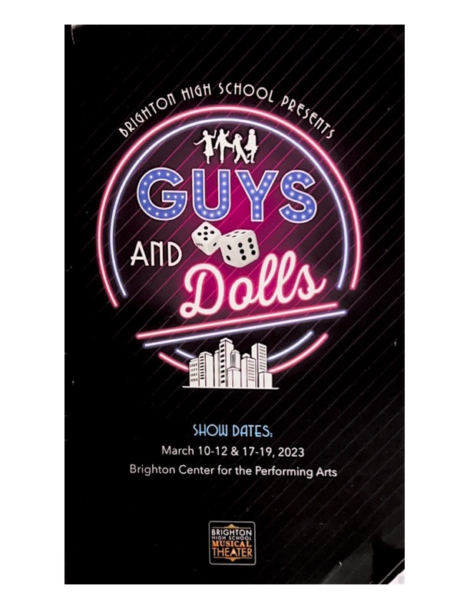

When the lights finally went out and the production started, I knew I would be in for a ride. With the show starting and set pieces moving, the intro of the play moved me. The show starts with an instrumental introduction guiding you into the world of New York City in the 1950’s, watching the people on stage live the life of pedestrians was like sitting there people watching. There was a lady with a stroller that would pick up her baby and reveal that in the blanket was silverware she was selling, there was also a blind man that would stand at the corner with his cane and glasses, but as soon as some girls came walking by, he lowers his sunglasses to take a peek. This moment before the story starts puts you into the world and gives you a glimpse of what the show is going to be like.

The main protagonist of the play was a man named Nathen Detroit, a gambling man living in New York City. His main goal throughout the production is to get an illegal craps game going so he can make some money off the bets but faces opposing pressure from his fiancé of 14 years, Miss Adelaide, to finally get married and stop all the illegal gambling. Detroit is faced with finding a place so that his customers can have a place to gamble but has no money to front for the place in mind, inevitably they move to the sewers and play their game of craps. Miss Adelaide finds out about Detroit's plans and is almost through with him at this point, Detroit finally realizes how hard it is to keep up his business of illegal gambling, so he stops and marries Miss Adelaide and starts working at a newsstand and changes his life for the better.

Two production elements that worked hand and hand together were the lighting and stage design. With how flashy New York City was in the 1950s, the design of the set when you walk in and find your seat is surreal. The lighting of the set and back wall with the glow of the signs on a 48-foot by 16-foot backdrop sets you into the world you are about to enter. With scene changes, the lighting would dim and move around, the back wall would change colors depending on the mood of the scene as the new set pieces were hulled in. One moment I enjoyed with these two production elements was when Detroit is calling his friend Joey, two spotlights shined on both set pieces of where they were calling from, making it more focused on what is there and what is going on rather than showing the whole empty stage. Another aspect of this scene I liked was how the audio was equalized when Detroit and Joey are on the phone, cutting out the lows and mid tones when they are on the phone and bringing it back when they step away.

The main theme from the show would have to be self-made luck, either winning the game for the bet or finding the woman through self-inflicted actions. While we live life, we sometimes feel lucky once in the while with a random good fortune, but to manufacture that good fortune is the whole goal of some of the characters in this production. A good example of this is when Nathen Detroit bets Sky Masterson to take Sarah Brown (a woman who would not be fond of him) on a date to Cuba, Sky takes her and inevitably falls in love with her and throws his bet with Nathen. An example of self-made luck in the real world is the new wave of stock and digital asset trading in today’s times. In recent years more people have been trying to make their luck by trading cryptocurrencies, NFTs, and pulling stock market moves like the GameStop stock. These people want to make money quickly and feel control over it, but in the end, there is no such thing as self-made luck, only luck itself.